Below is a 1957 $1 bill. Notice it’s labeled a Silver Certificate across the top and it certifies there is (something) on deposit in the Treasury …
On the bottom it finishes the top line and it finishes the sentence by describing what is on deposit in the Treasury … ONE DOLLAR in silver payable to the bearer on demand.
How much silver in one dollar?
According to the Coinage Act of 1792, one dollar is 24.1 grams of silver.
So before silver was removed from circulation by the Coinage Act of 1965, you could go into a bank and present this “claim” and receive one dollar in silver.
In other words, a dollar bill wasn’t money. It was only a claim on money … an IOU from the United State Treasury to you.
So the dollar bill was a convenient currency … easier to carry around than clunky silver dollars … but it was the first step in divorcing money (metal) from currency (paper).
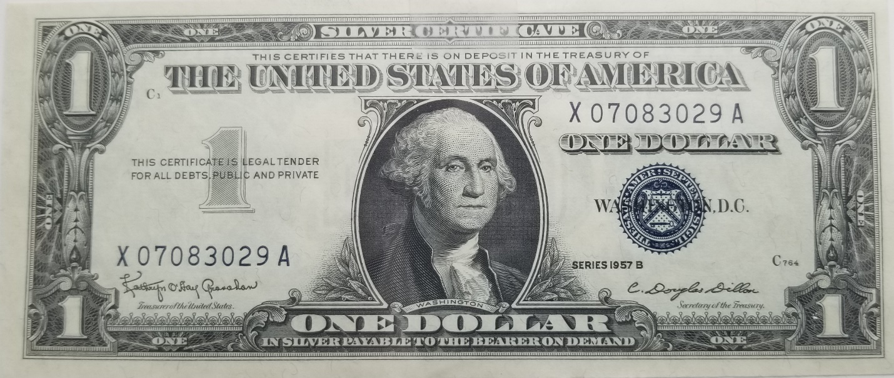

Of course, today’s dollar is not issued by the government (Treasury). Instead, it’s issued by a private banking cartel called The Federal Reserve.
While the counterfeit dollar looks very similar, there are some notable difference …
At the top, it’s no longer a Silver Certificate, but a Federal Reserve Note.
In simple terms a “note” is an IOU … like the promissory note you sign when you get a mortgage or car loan.
In other words, the Federal Reserve owes you one dollar.
But notice there is no certification that there’s anything backing it … nothing on deposit anywhere.
And on the bottom, it just says the bill is “ONE DOLLAR”. One dollar of … what? And what’s one dollar worth?
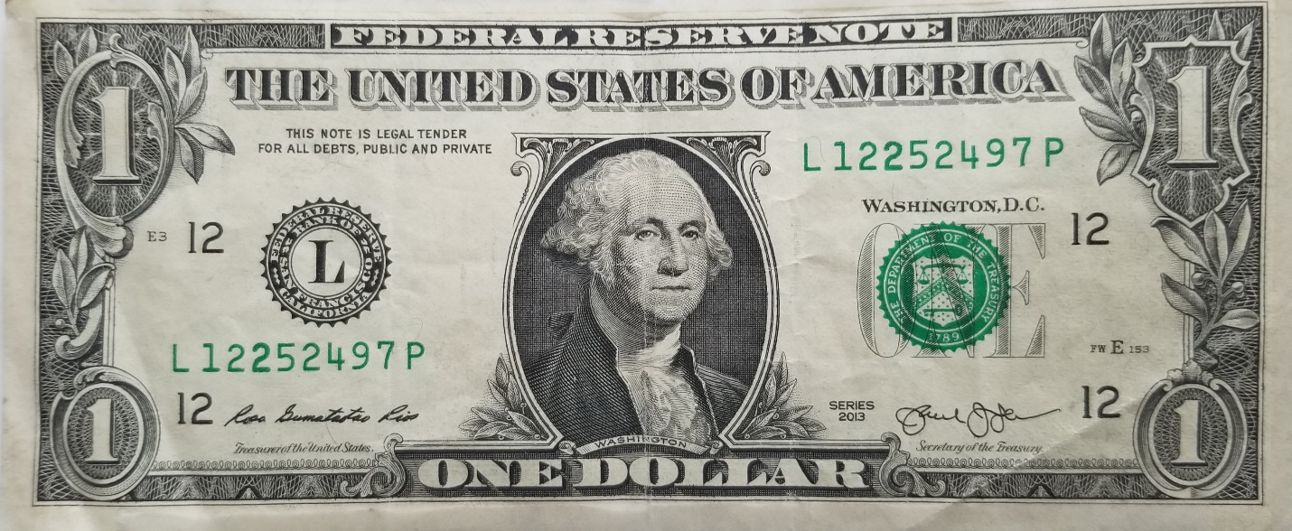
Of course, what a dollar is worth is a VERY important question.
If you could go back to 1957 (the date on the silver certificate), you’d find a gallon of gas was about 28 cents. So a dollar would buy about 3.5 gallons.
In July 2020, a gallon of gas is about $2.19 cents … and this is in the midst of a depressed oil market due to the COVID-19 shutdown.
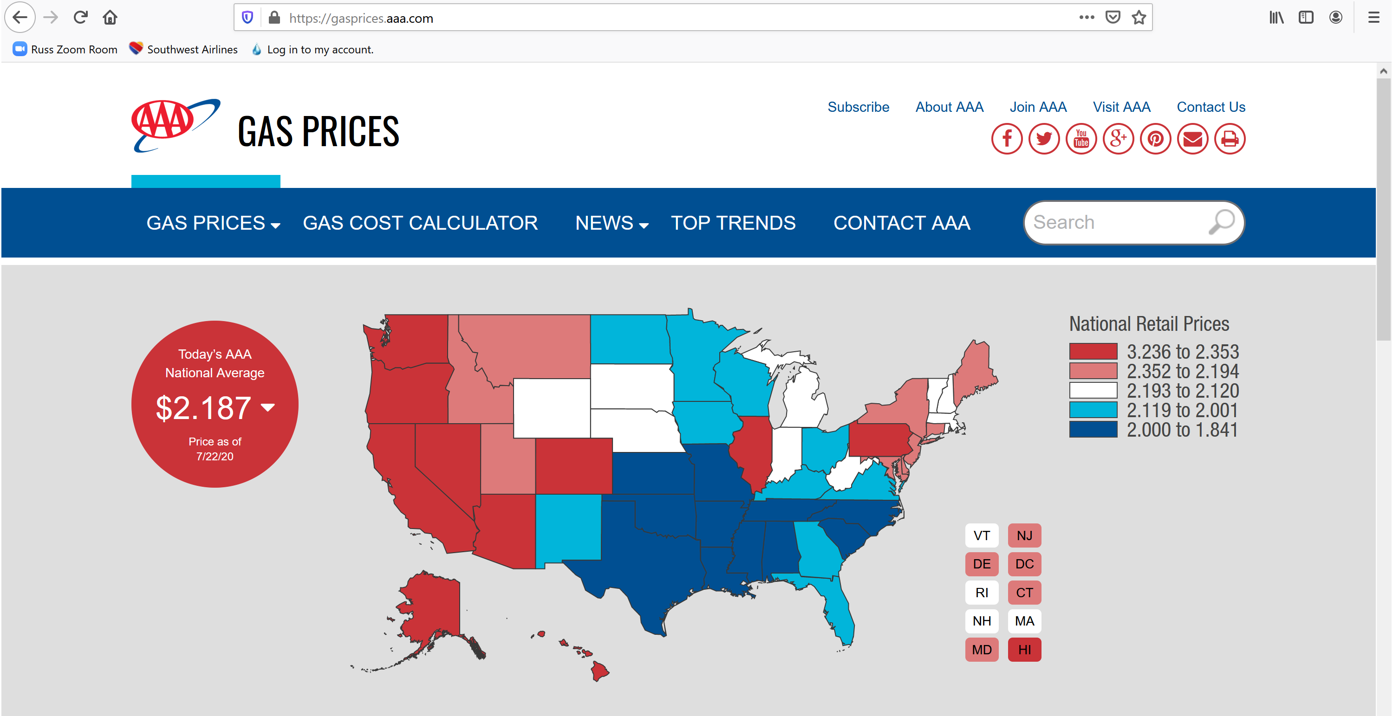
According to Coinflation.com, a dollar of silver is worth about $17.75 in paper dollars as of July 22, 2020.
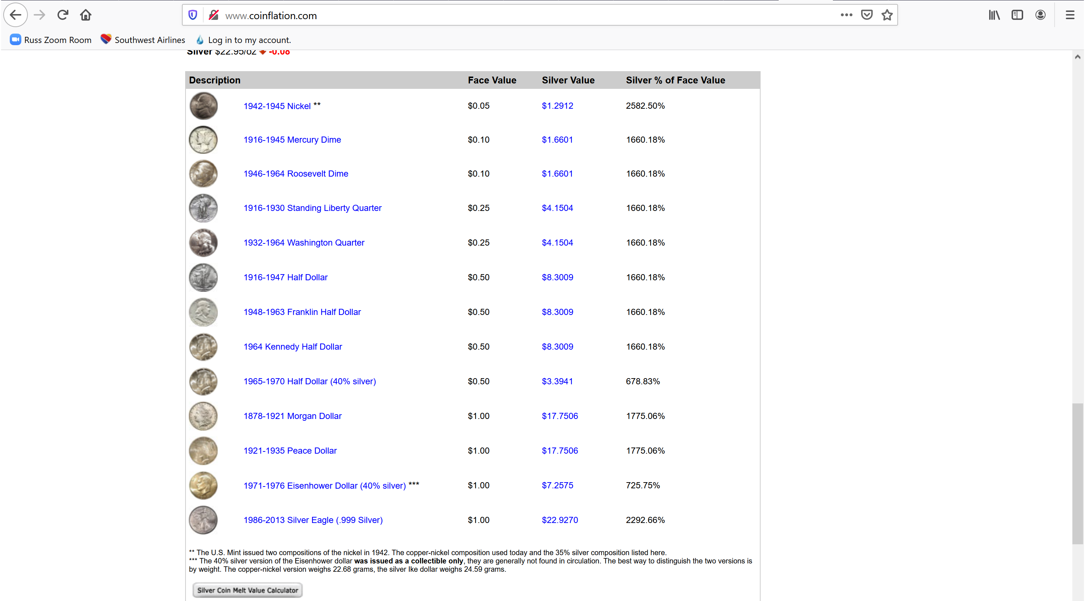
So a dollar of silver in 1957 would buy about 3.5 gallons of gas …
$1.00 / 28 cents per gallon = 3.57 gallons
And a dollar of silver in 2020 would buy just over 8 gallons of gas …
$17.75 / 2.19 per gallon = 8.10 gallons
BUT a Federal Reserve Note in 2020 will only buy less than half a gallon …
$1.00 / 2.19 = .46 gallons

This is the important difference between money (metal) and currency (paper). Keep this in mind when choosing how to store excess liquid wealth for long periods of time.

Good investing!
Russell Gray
Financial Strategist
Co-Host of The Real Estate Guys™ Radio Show

